Training games with other games

Rover Vos

12235834

Klagenfurt, 15/05/2023

# Introduction

The gaming industry has become one of the largest industries about, with 154.6 Billion USD revenue in 2021 and eSports having 1.384 Billion USD revenue in 2022(Statista). Lots of people are playing games and a lot of them want to be really good at games. Some even to such an extend that they compete in big tournament and are considered professional gamers, just like professional sports players. We don’t call videogames E-sports for no reason after all.

As games have become such a large market and people are trying to become professionals there is a new need for ways to improve at games. You can of course play your game of choice to become better, however people are also looking into different ways to become better at games fast. Because of this in this paper I’m looking at games which can be played to improve at other games. Mainly games specifically made to improve performance of players.

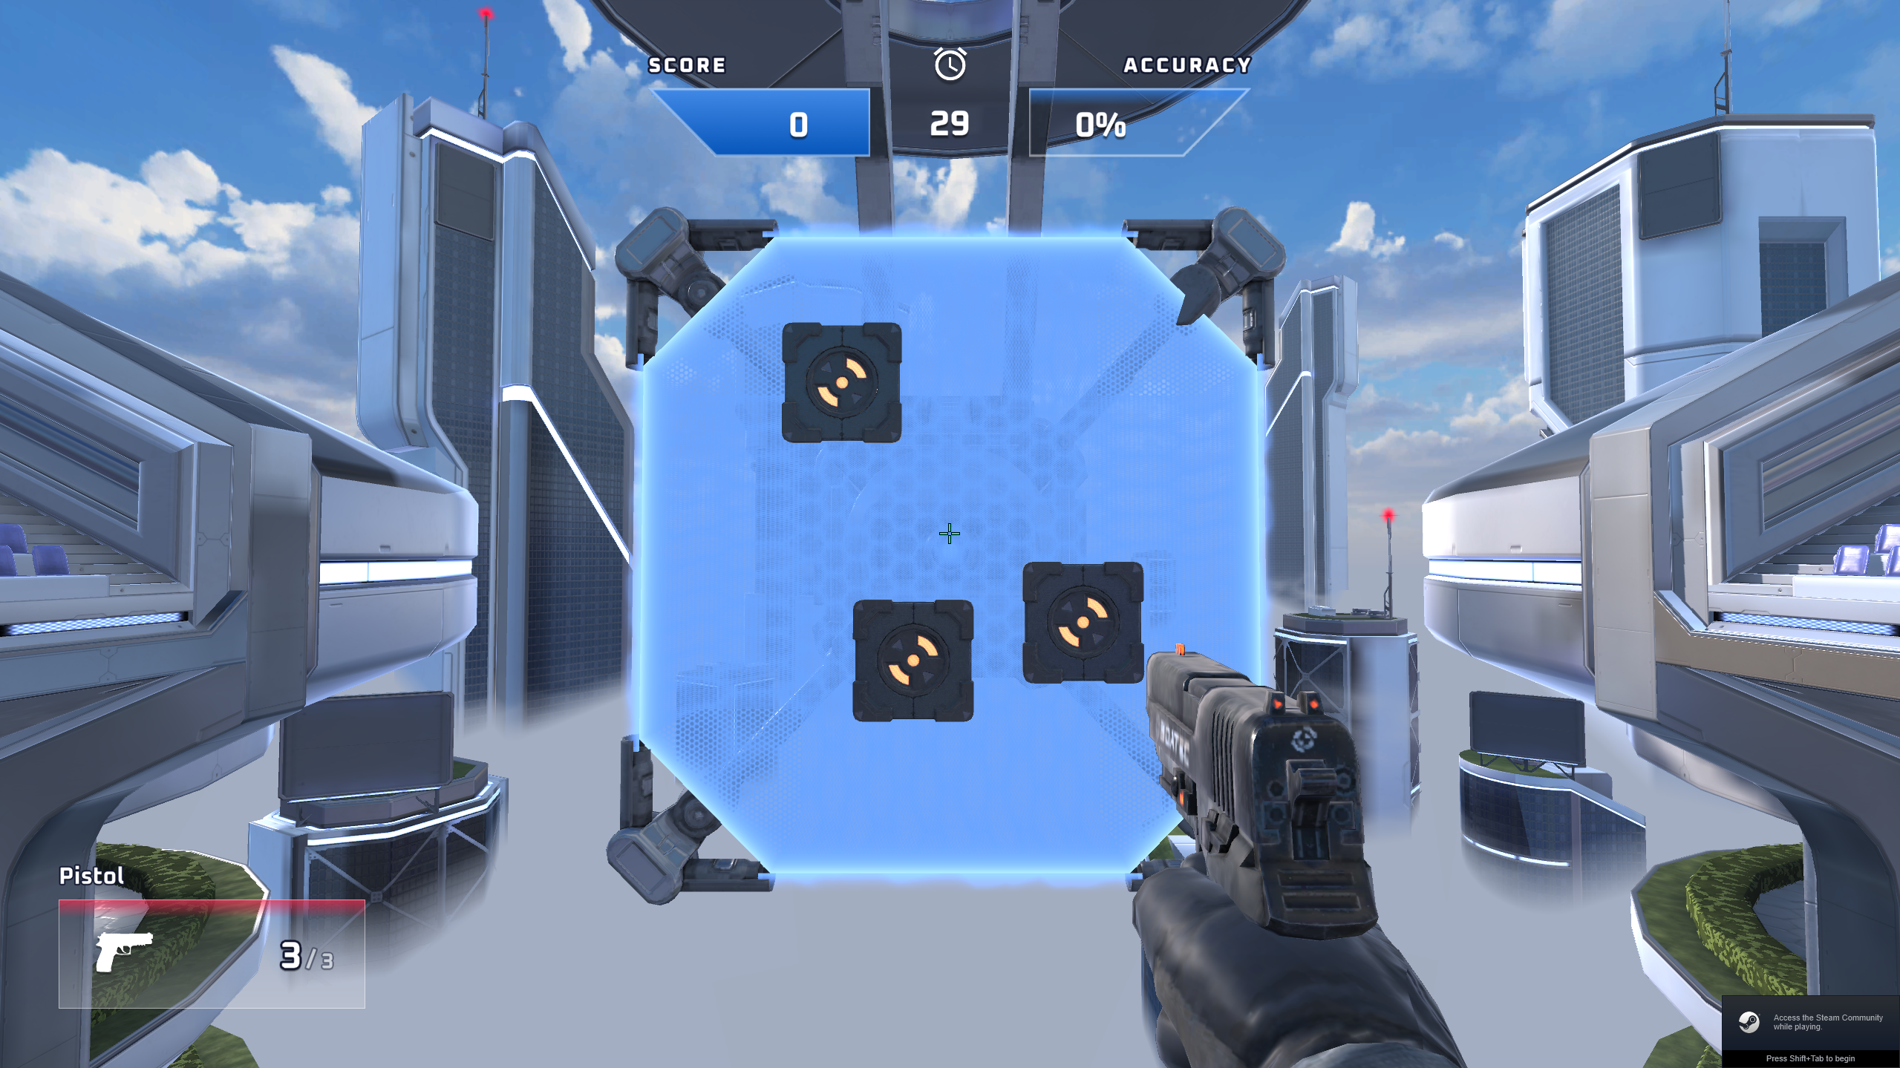

# Example

***3D Aim Trainer***

*3D Aim Trainer(*3D Aim Trainer, 2021*)* is a tool for people to become better at First Person Shooter games. There are many different game modes that can help practice aiming, speed, etc. The game also has dedicated modes for specific games so that the player can be come better at the game of their choice. The game isn’t just shoot things and get better, there is also very accurate, interesting and useful data which tell you what is going wrong and what you could do better to improve.  
For completion sake and because it is used in the literature I use. A similar product to *3D Aim Trainer* is *Aim Lab (REFERENCE).* Same concept different developers. Aim lab is used by 4000-5000 different people on daily basis(Steam charts) while 3D Aim Trainer is only used by 75 people per day as per steam charts. However 3D Aim Trainer also has a free to use web version for which I couldn’t find the data and I suppose that most people use that version.

***Castle Pineapplia***

*Castle Pineapplia* is a game made for *World of Warcraft* (Blizzard Entertainment. 2004)by TacticalAirHorse in 2022. The game teaches players the mechanics of the Castle Nathria raid. Raid’s in WoW are large areas with many bosses to defeat. You defeat these bosses with 10-40 players and everyone has to the mechanics correctly or you won’t defeat the boss. These tools help the players to learn the mechanics of a fight without having to go through the real fight multiple times wasting your and everyone’s time. Almost everyone wants to defeat the bosses as fast as possible.

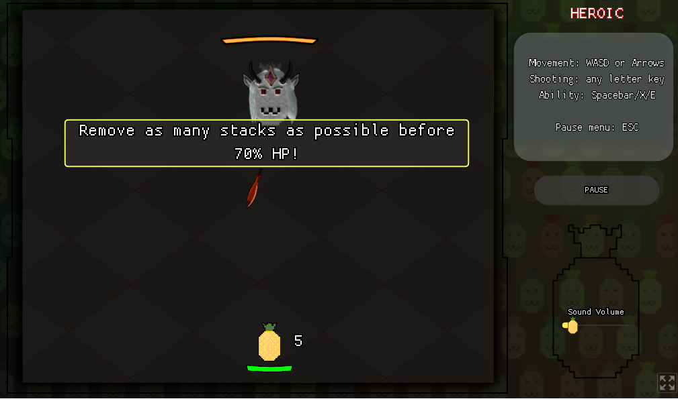

# Discussion

Speed and accuracy

FSA Flicking skill assessment

In a paper by Roldan and Prasetyo they claim that the usage of *Aim Lab* can give a significant performance boost. They tested 6 players who used *Aim Lab* for one week and saw a performance increase. However I question the accuracy of this research as the player also played the *Valorant(Riot Games 2020)* during those days and they didn’t measure the amount of time they played *Valorant.* In addition to this they don’t have a control group, so I question if the performance increase was from playing *Valorant* of from *Aim Lab*.

I would like research to be done in the following topics:

I think it could be invaluable if the same research is done, but his time with a control group and with a set amount of hours played in *Valorant*.

I would like to know which form of aim training is the best. Which mode of aim training is most efficient. Tiles, orbs, bots, flicking training and whatever else is available.

When is the best moment to train, before or after playing the main game. Does warming up with an aim trainer before playing increase performance?

For who is this software more useful, beginners or advanced players? Would it be more valuable for either group to just focus on the main game instead of aim training.

What is the golden mean of aim training. How much time is too much training and how much is too little. What is the perfect amount of time spend training.

Lastly I would like to know where players look while playing FPS games. This has less to do with aim training, but I think it can be a valuable peace of information for players to become better at FPS games.

* *Discuss research as far as available (search for related research on Google Scholar)*
* *If only limited research can be found, try to discuss the issue, e.g. challenges, market potentials, societal impact / relevance, etc.*

# References

3D Aim Trainer*.* 2021*. 3D Aim Trainer.* Dendermonde, Belgium: 3D Aim Trainer

TacticalAirHorse. 2022. *Castle Pineapplia.* Itch.io: TacticalAirHorse

Blizzard Entertainment. 2004. *World of Warcraft.* Irvine, California: Blizzard Entertainment

Riot Games. 2020. *Valorant*. West Los Angeles, California: Riot Games

<https://www.statista.com/markets/417/topic/478/video-gaming-esports/#overview>

Long-Term Motor Learning in the “Wild” With High Volume Video Game Data

https://steamcharts.com/app/1600530